Team 2

Mohammed Khoshkhoiyazdi – Collin Cavanaugh

Professor Hailat

March 18, 2022

Project 2

**Problem Statement:**

This program is an online address book application and the connection between user and the address book is via network sockets. Multiple users can connect to the server and use the online address book. To ADD, DELETE any contact information in the book or SHUTDOWN the server and client, client needs to sign in to the server, but the rest of the actions do not require to be logged in to the server. After, the client and server get connected, user sends a message via client to server. Then server based on the received message either make changes to the online address book and sends a confirmation message or provides and send back the information saved in the list to the client which would print out the information for the user. Moreover, server can provide information about the list of users that have been connected to the server to each of the clients.

**Read Me:**

To run this program, first you need to run the server program via visual studio, and then run the client program. You can run the client program multiple times and it will connect to server. Then you type the commands and get the information form server.

**Delegations:**

Mohammed Khoshkhoiyazdi:

* Implemented Client file
* Worked on the ADD and LIST functions in the Server file with the other teammate.
* Added the changes for multithreading in the Client File
* Worked on the WHO, LOGOUT, SHUTDOWN in the Server file with the other teammate.
* Debugged and cleaned up the code with the other teammate

Collin Cavanaugh:

* Implemented Server file
* Added the changes for multithreading in the Server file.
* Implemented LOGIN, LOOKUP, and Improved the other functions.
* Debugged and cleaned up the code with the other teammate

**Test Plan:**

|  |  |  |  |  |  |  |
| --- | --- | --- | --- | --- | --- | --- |
| Test # | Valid / Invalid Data | Description of test | Input Value | Expected Output | Actual Output | Test Pass / Fail |
| 1 | Valid | This test examines if the program runs without any error | Runs the client and server program | Runs perfectly | Runs perfectly | pass |
| 2 | valid | This test examines whether client and server get connected. When client cannot connect to server it will try for 5 times to connect to the server and when it does not connect after 5 times it will print out and error message | Start the client and server program |  |  | pass |
| 3 | valid | This test examines whether we can add a new contact information into the address book | ADD moe ky 123-123-1234 | 200 OK  The new ID number is 1001 | 200 OK  The new ID number is 1001 | pass |
| 4 | valid | This test examines whether we can get the information saved in the list form the server | LIST | 200 OK  The list of records in the book:  1001 Moe Ky 123-123-1234 | 200 OK  The list of records in the book:  1001 Moe Ky 123-123-1234 | pass |
| 5 | valid | This test examine if the server checks whether the message received is formatted correctly or not | ADD Moe Ky 1231231234 | 403 message format error | 403 message format error | pass |
| 6 | valid | This test examines if the server checks whether the message received is formatted correctly or not | List | 400 invalid command | 400 invalid command | pass |
| 7 | valid | This test examines if we can delete a contact info form the address book. | DELETE 1001 | 200 OK | 200 OK | pass |
| 8 | valid | This test examines if we can allow the user to shut down the server | SHUTDOWN | 200 OK | 200 OK | pass |
| 9 | Valid | This test examines if we can terminate the client. | QUIT | 200 OK | 200 OK | pass |
| 10 | Valid | This test examines if the input and outputs in the client are saved in the README.txt file. | Open README.txt | ADD moe ky 123-123-1234  200 OK  the new record ID is 1001  LIST  200 OK  The list of records in the book:  1001 moe ky 123-123-1234  ADD moe ky 1231231234  403 message format error  list  400 invalid command  List  400 invalid command  DELETE 1001  200 OK  SHUTDOWN  200 OK  QUIT | ADD moe ky 123-123-1234  200 OK  the new record ID is 1001  LIST  200 OK  The list of records in the book:  1001 moe ky 123-123-1234  ADD moe ky 1231231234  403 message format error  list  400 invalid command  List  400 invalid command  DELETE 1001  200 OK  SHUTDOWN  200 OK  QUIT | pass |
| 11 | Valid | This test examines if we add new contact info, it will be added to the online address book txt file. | moe ky 123-123-1234  collin cov 466-456-4567  sohi taj 123-123-1234 | 1001 moe ky 123-123-1234  1002 collin cov 466-456-4567  1003 sohi taj 123-123-1234 | 1001 moe ky 123-123-1234  1002 collin cov 466-456-4567  1003 sohi taj 123-123-1234 | pass |
| 12 | Valid | This test examines if we can run multiple clients at the same time and connect them to server | Run two clients and the server. | Both got connected to the server | Both got connected to the server | Pass |
| 13 | Valid | This test shows that if we can login to the server. | LOGIN john john01 | LOGIN john john01  200 OK | LOGIN john john01  200 OK | Pass |
| 14 | Valid | This test examines if we can logout from the server. After we log out server updates the list of the user names. | LOGOUT | LOGOUT  200 OK | LOGOUT  200 OK | Pass |
| 15 | Valid | This test examines if we can access to some of the functions such as ADD or DELETE if user is not logged in | DELETE  Or  >ADD mo mo 123-123-1234 | >ADD mo mo 123-123-1234  400 invalid command | >ADD mo mo 123-123-1234  400 invalid command | Pass |
| 16 | Valid | This test examines the WHO function. by typing WHO, server will send the list of all the clients that are logged in. | WHO | john 127.0.0.1  root 127.0.0.1 | john 127.0.0.1  root 127.0.0.1 | Pass |
| 17 | Valid | this test examines the LOOKUP function. the user chooses a number between 1-3 best on whether if he wants to search with the first name, last name and phone number and then server send a list of all of the matches. | LOOKUP 1 john | >LOOKUP 1 john  200 OK  Here are the address that match:  1001 john j 111-111-1111  1002 john c 222-222-2222  1001 john p 333-333-3333 | >LOOKUP 1 john  200 OK  Here are the address that match:  1001 john j 111-111-1111  1002 john c 222-222-2222  1001 john p 333-333-3333 | Pass |
| 18 | Valid | This test examines the SHUTDOWN function. it basically shuts down the server and the client and the only client that can shuts the system down is root. | SHUTDOWN | Closes both server and client | Closes both server and client | Pass |

**Screenshots:**

Test1:

Test2:

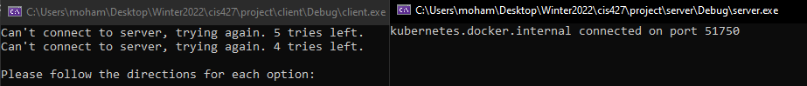

Test3:

Test4:

Test5:

Test6:

Test7:

Test8:

Test9:

Test 10:

Test 11:

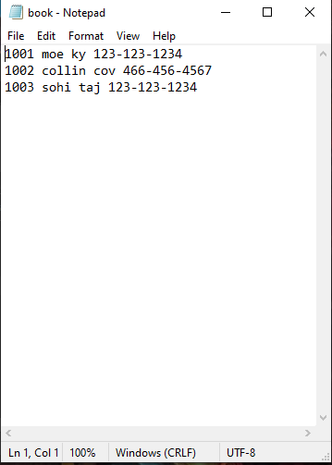

Test 12:

Test 13:

Test 14:

Test 15:

Test 16:

Test 18:

